Andrew Cook

#### Superintendent

632-5931

Brian George

*Middle School/*

*High School Principal*

632-5923

Bethellen Mannix

*Elementary Principal/*

*Special Education Chairperson*

632-5222

Joann Searles

*District Treasurer*

632-5931

BOARD OF EDUCATION

Brian Getty

## President

Janine Thomas

## Vice President

Philip Jessen

Adam Fish

Ronald Smith

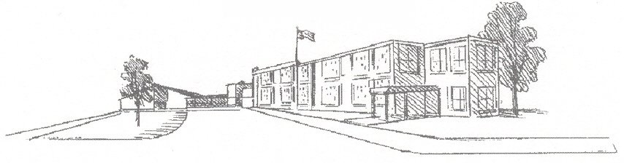

*Hartford Central School*

### PO Box 79

*Hartford, New York 12838*

*518-632-5222*

*www.hartfordcsd.org*

*"Hartford Central School, a community of educators, students, parents, and friends,*

*dedicates itself to developing citizens who are productive and compassionate, and who,*

*through their creativity and responsibility, will be assets to the greater community."*

***Opt-Out for NYS BMI/ WSC Reporting for the 2019 - 2020 School Year***

As part of a required school health examination, a student is weighed and his/her height is measured. These numbers are used to figure out the student’s body mass index (BMI) and weight status category (WSC). This information helps the doctor or nurse know if the student’s weight is in a healthy range or is too high or too low. Recent changes to the New York State Education Law require that BMI and weight status group be included as part of the student’s school health examination. A sample of school districts will be selected to take part in a survey by the New York State Department of Health. If our school is selected to be part of the survey, we will be reporting to New York State Department of Health information about our students’ weight status groups. Only summary information is sent. No names and no information about individual students are sent. However, you may choose to have your child’s information excluded from this survey report.

The information sent to the New York State Department of Health will help health officials develop programs that make it easier for children to be healthier.

If you do not wish to have your child’s weight status group information included as part of the Health Department’s survey this year, please print and sign your name below and return this form to:

Alyssa Arlen, MSN, RN, School Nurse

[aarlen@hartfordcsd.org](mailto:aarlen@hartfordcsd.org) or Fax 518-632-5231

**Please do not include my child’s weight status information in the *2019-2020* School Survey.**

______________________________________ ___________________

Print Student’s First and Last Name Student’s Grade

_____________________________ _________________________ _________________

Print Parent/ Guardian’s Name Parent/ Guardian’s Signature Date