Registration on ScheduleGalaxy is now opened!

Any person can now become a user of ScheduleGalaxy.

ScheduleGalaxy now recognizes accounts for Athletic Directors (or other school manager) and public.

In order to register follow the link “Register” in the top navigation bar:

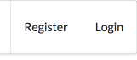

Provide all the necessary information in the registration form:

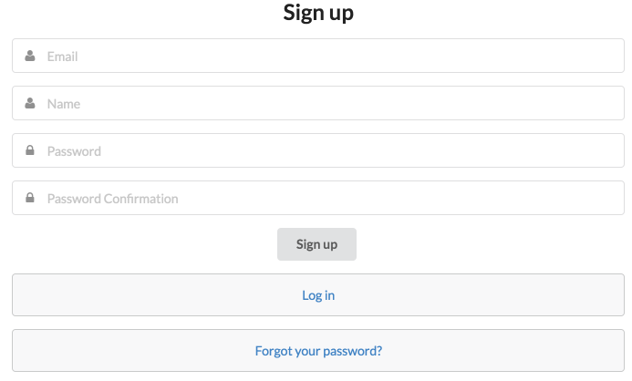

When you successfully registered, you can now subscribe to schedules, you are interested in, using button “Subscribe to schedule” on the team schedule page:

(B) 78TH Basketball — ScheduleGalaxy 2017-11-01 13-24-21.png

If you want to unsubscribe from a schedule, you can click “Unsubscribe”:

(B) 78TH Basketball — ScheduleGalaxy 2017-11-01 13-18-07.png

The whole list of schedules, you are subscribed to, you can see in the left menu:

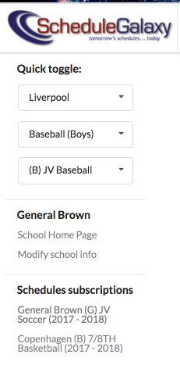

You can quickly access now your teams from the left menu and easily manage your subscriptions.